September 2022 V2.0
REDCap
WVU IRB
Electronic Informed Consent
Modification Guide
WVU OHRP
REDCap Electronic Informed Consent (eIC)
- Use these instructions ONLY when you are replacing a document in already approved eIC project
- There are two options for replacing a consent form in REDCap and both will be discussed in this guide.
  - Creating a New Project For the Updated/Amended Consent Form OR
  - Uploading an Amended Consent Form to an Existing Project

Option 1: Creating a New Project for the Updated/Amended Consent Form
In the event of a consent form amendment, WVU OHRP and WVCTSI best practices recommend making a new project to house the amended form to minimize the risk of error. This can be done by using the “duplicate project” function within REDCap. Before duplicating the project, disable the automated invitations in the original project.
To do this, click on the “designer” tab on the project home page. Then, click the green “automated invitations” button to the right of the consent form survey.
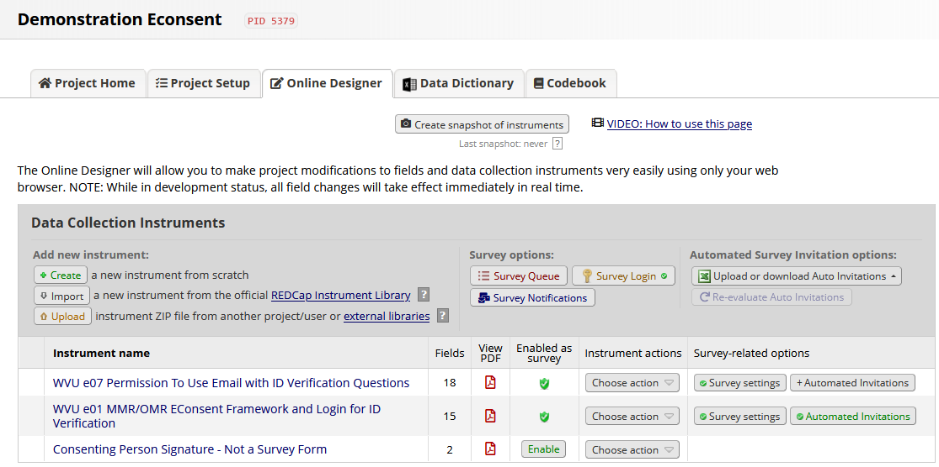
In the window that appears, scroll to the bottom of the window, and click “not active” under step 4. Then, click save. The window will automatically close.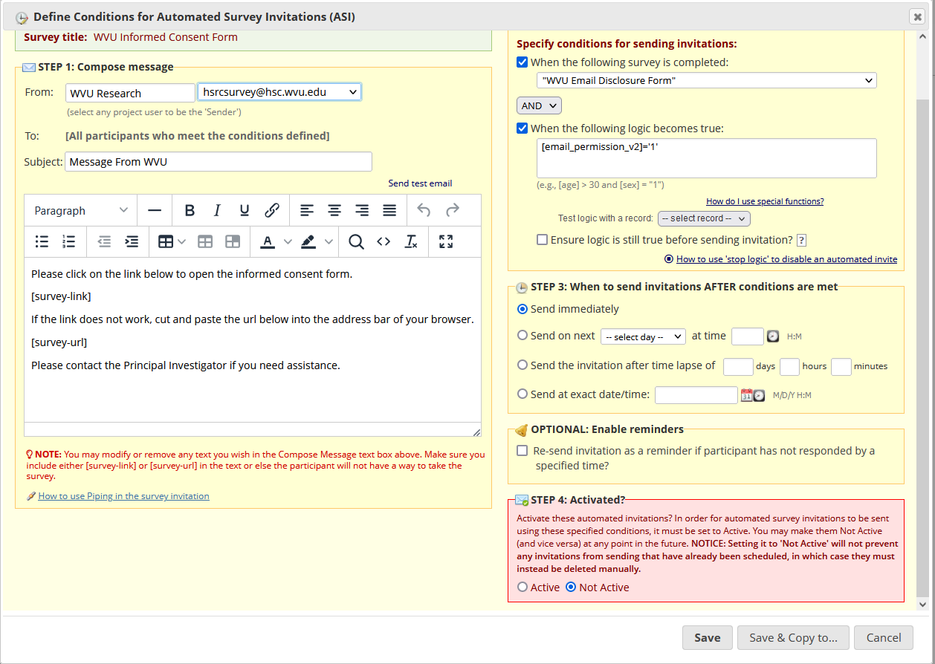
The “automated invitations” button is now red, to indicate that it is now inactive.
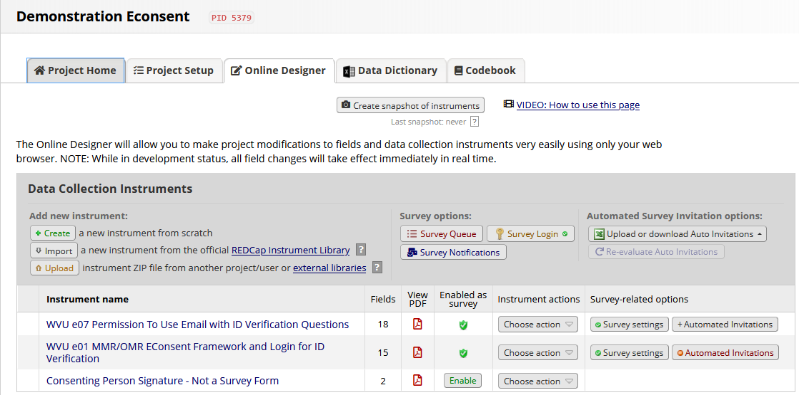
Click on the “project setup” tab, and then click the “other functionality” tab at the top of the page.
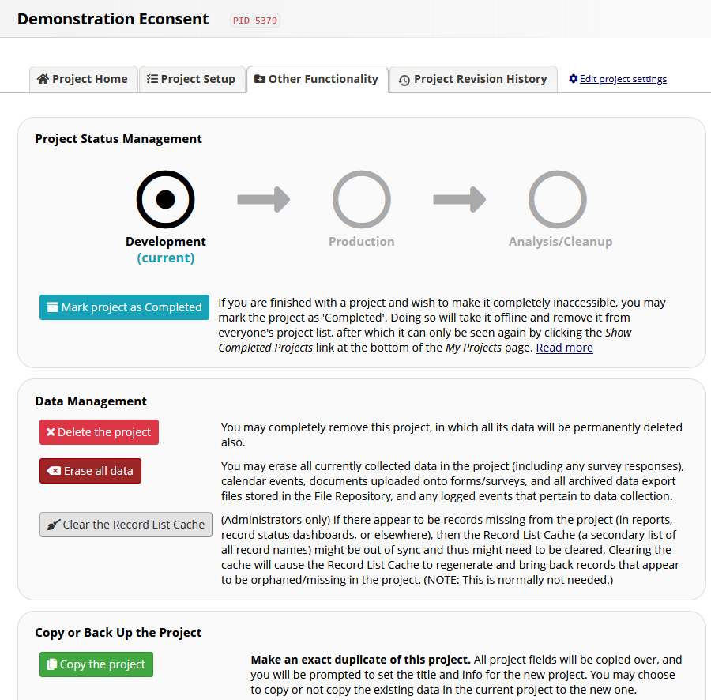
Click the “copy the project” button. A new window will open.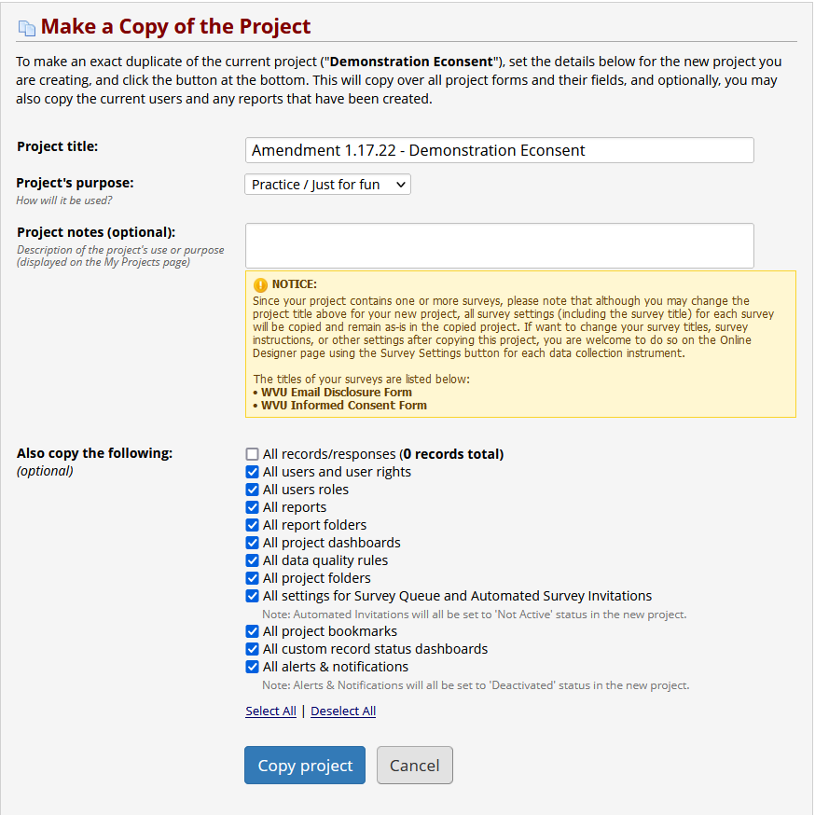
Update the project title to reflect the amendment status of the consent form with the PI name and WVU+kc protocol number, for example: Smith 1234528591 Title of Study Here Amendment1. Select all items from the existing project except for existing records/responses. Then, click “copy project.” The new project automatically opens to the project setup page.
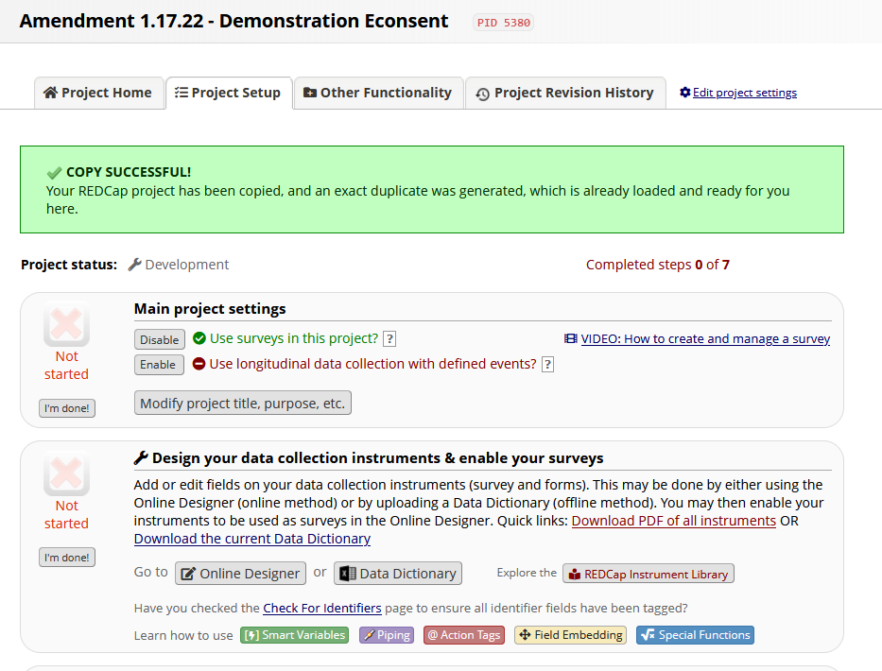
Return to the project designer page and click the name of the instrument that houses the existing consent form.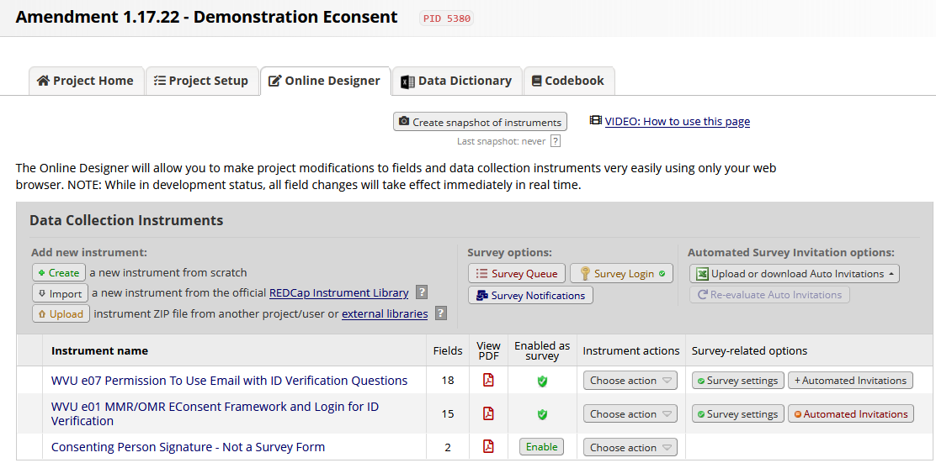
Scroll down to the “copy_download” field. Click the pencil icon in the upper left corner of the field.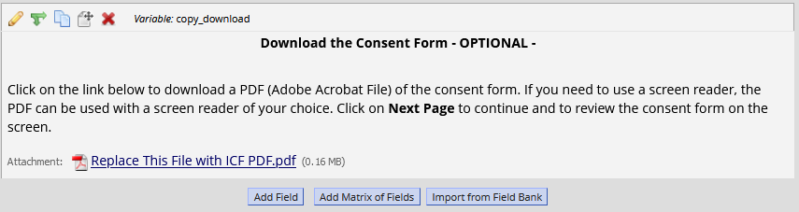
A new window will open. Next to the attached file, click the “remove” button. This will remove the existing consent form PDF and allow you to upload the amended form. Then, click “upload file.” Another window will open; click “browse” and select the amended form PDF from your computer. Then, click “upload file,” and “save.”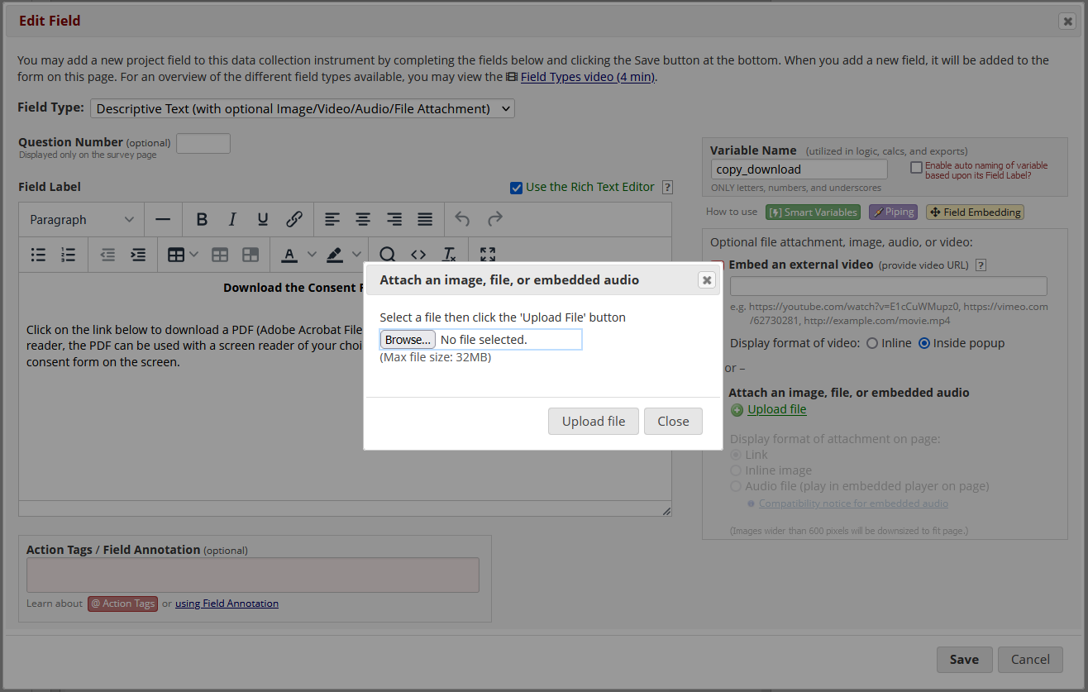
Repeat this process for the fields with images of the consent form. After uploading the image, select “inline image” to allow the page to be displayed within the survey. If the amended consent form is a different length than the previous consent form, additional fields can be added or removed by using the “copy” function (two boxes stacked on top of one another) or the “delete” function (the red “X”) in the upper left corner of the field.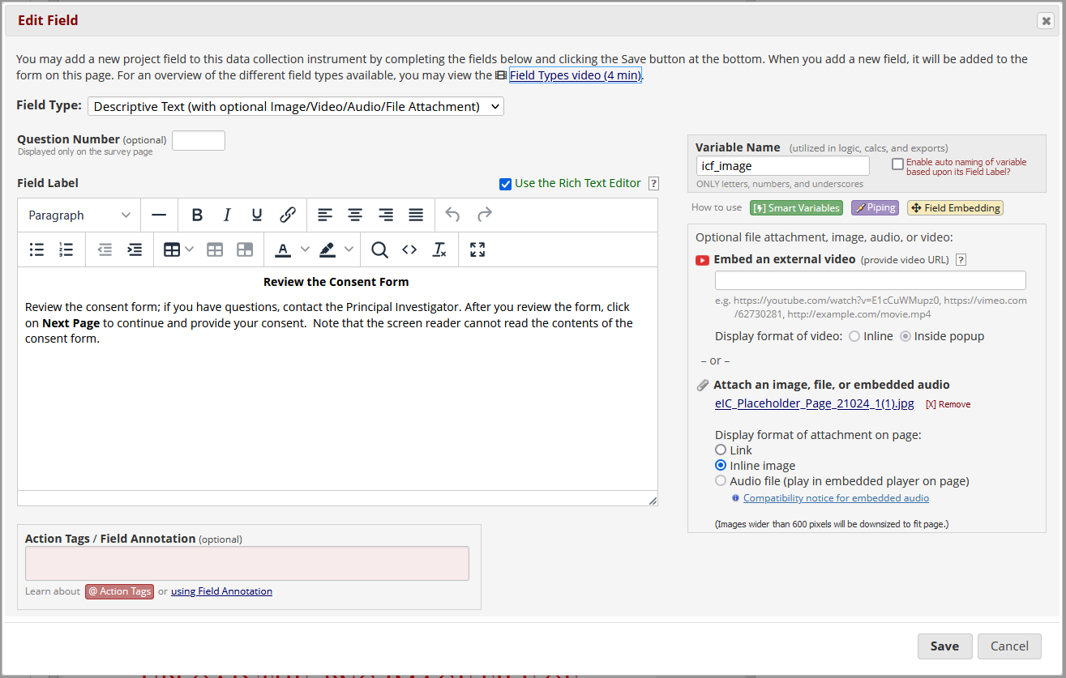
The last step is to enable the automated invitation function again. Return to the designer page and click on the red “automated invitations” button to the right of the consent form. Scroll to the bottom of the window and click “active” under step 4. Then, click save.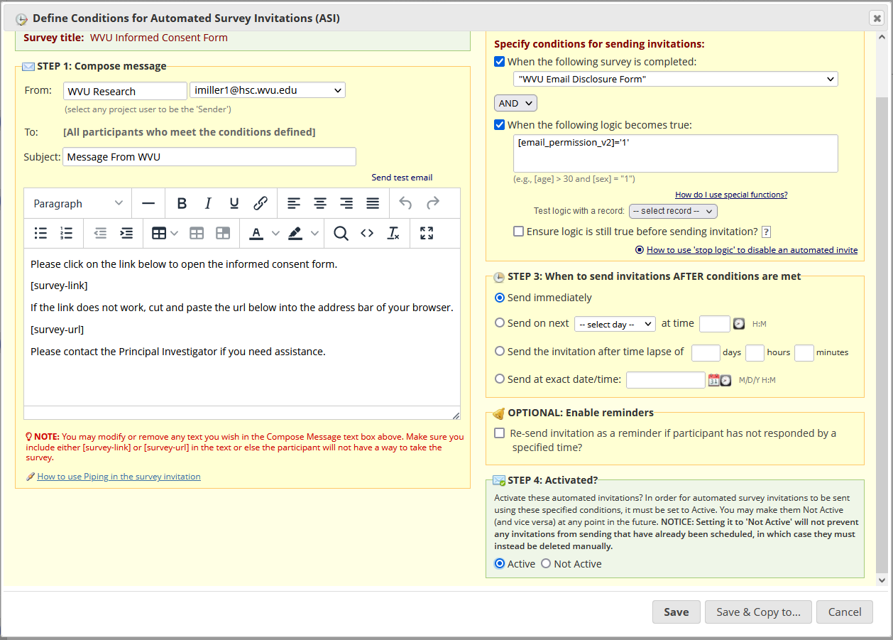
The amended consent form has now been set up and you can resume consenting participants in the standard fashion.

Option 2: Uploading an Amended Consent Form to an Existing Project
In order to maintain the integrity of data collected within a REDCap eIC project, amended consent forms must be uploaded to the existing project in a specific way. Any modifications made to the current EIC instrument will affect all existing records.
First, navigate to the “Designer” page of the REDCap project. Enter draft mode at the top of the webpage to begin making modifications to the project.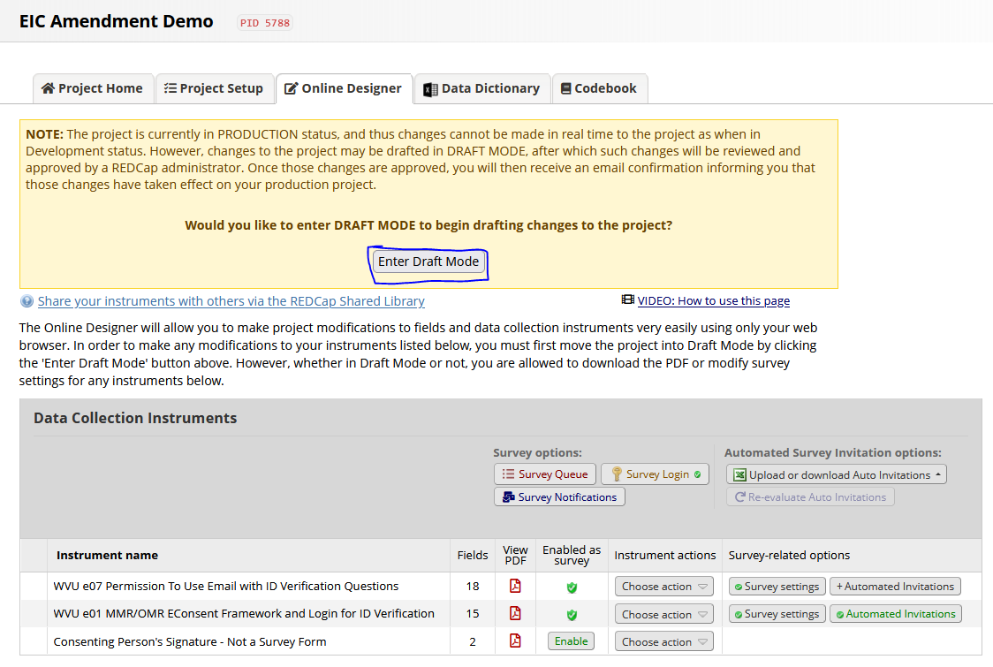
Once this has been done successfully, you will receive a confirmation message at the top of the webpage.

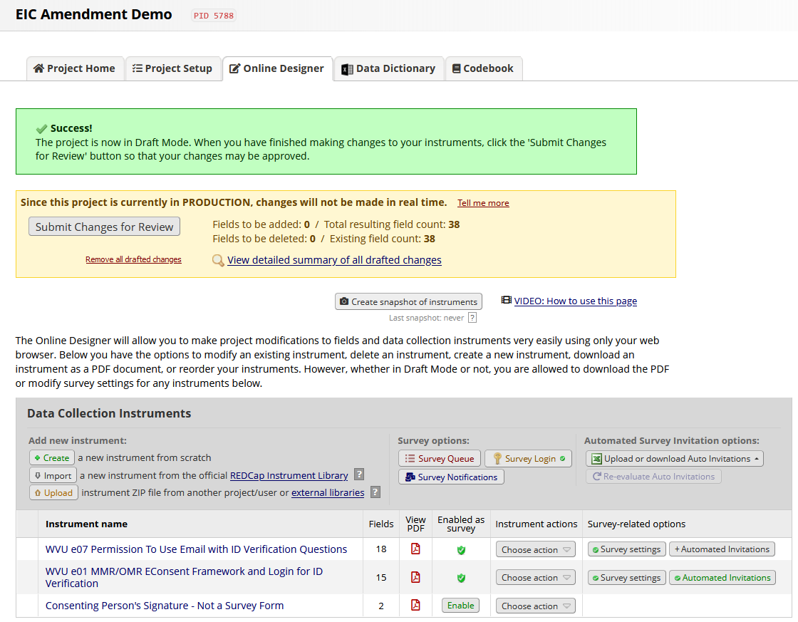
To prevent the outdated consent form from being sent to new participants, the automated invitation function for the instrument must be disabled. Click on the green button labeled “automated invitations” to the right of the instrument housing the existing consent form.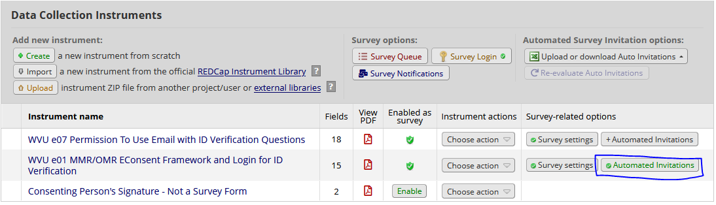
A new window will open. Scroll down to step 4 and click “not active.” Then, click save. The button labeled “automated invitations” will have turned red to indicate that it is currently inactive.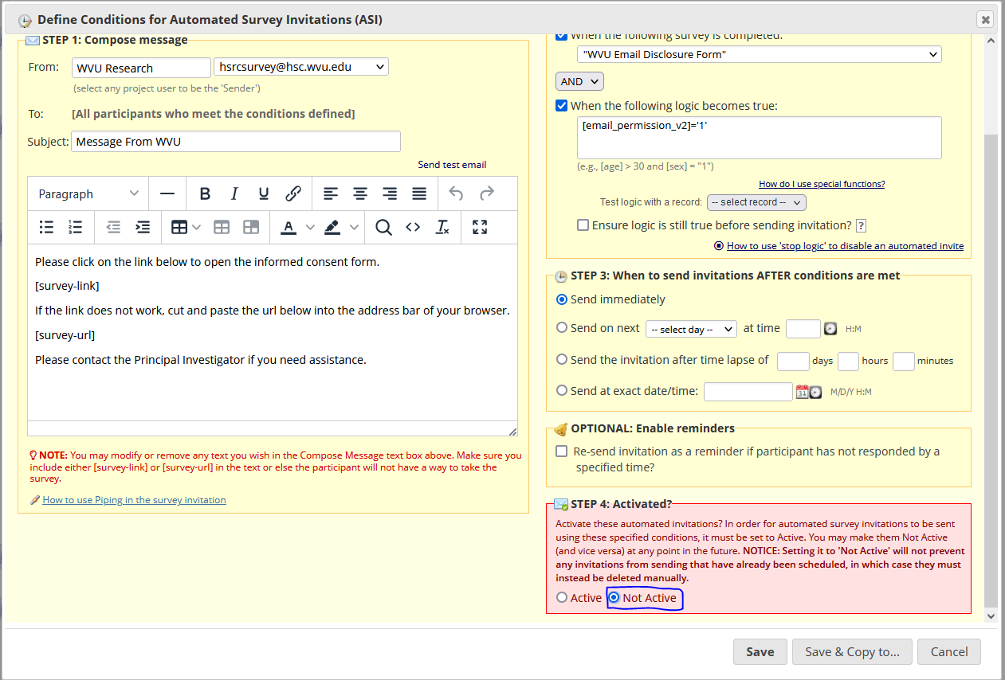
Next, click the dropdown menu labeled “choose actions” to the right of the consent form instrument. Click “copy;” a new window will open to allow you to enter a title for the copied instrument as well as the suffix to be added to the copied fields. It is recommended by CTSI to include “AMENDED” followed by the amendment date at the start of the copied instrument’s title.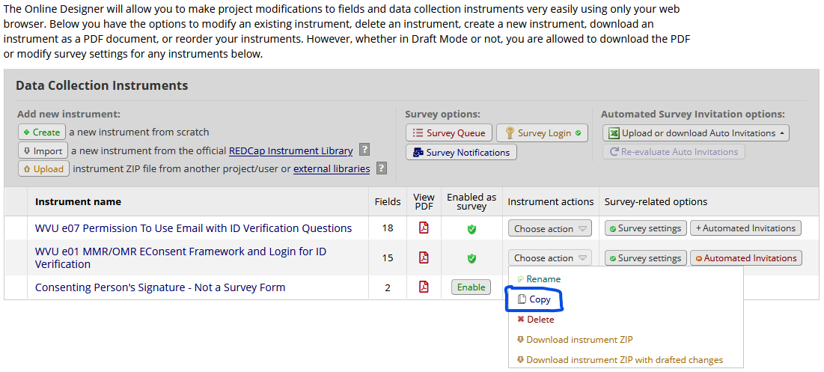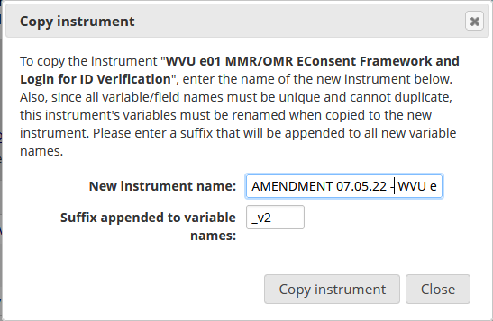
Once you have modified the copied instrument title and suffixes, click “copy instrument.” The copied instrument will immediately appear at the bottom of the listed instruments. Please note that instruments created while the project is in production mode cannot be enabled as surveys until the drafted changes to the project have been submitted and approved by the REDCap Administrator. To submit drafted changes for review, click the button labeled “submit changes for review” at the top of the page.
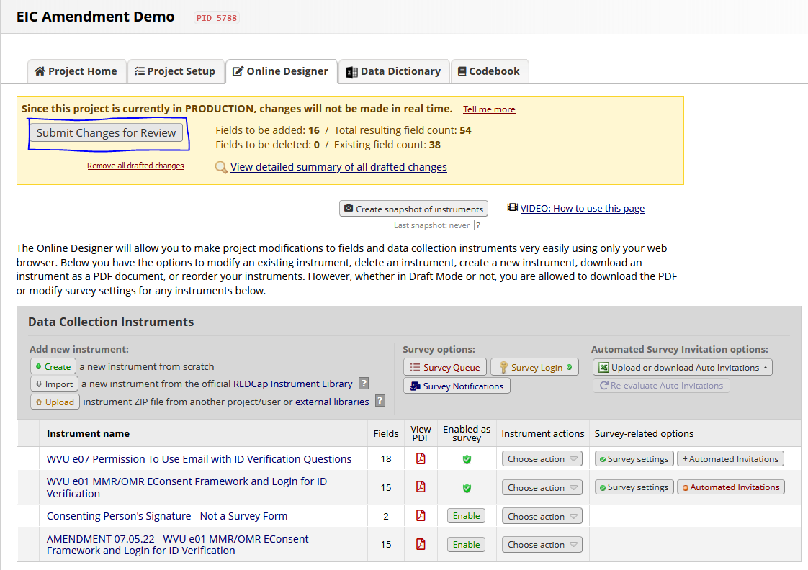
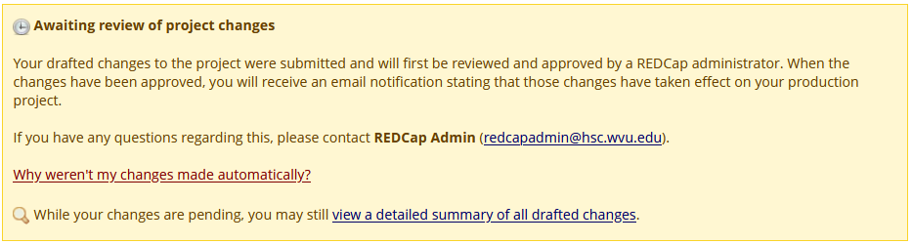
Once the REDCap Administrator has approved the drafted changes to the project, you will receive an email notification and the new instrument will immediately be enabled as a survey.
Next, return to the project designer page and enable draft mode again. To modify the order of instruments, hover your mouse cursor to the left of the instrument you want to move. Click and hold the arrows that appear, then drag the instrument up or down to change its location. Once any changes to the instrument order have been made, click on the name of the amendment instrument.
Scroll down to the field that houses the consent form PDF download. Click on the pencil icon in the upper left corner of the field to begin editing it.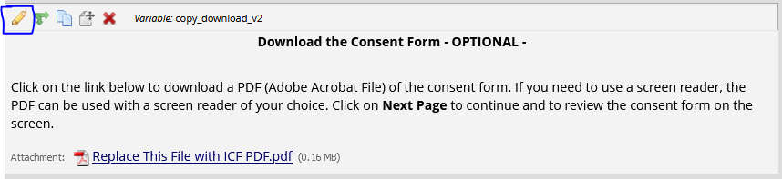
Remove the existing consent form.
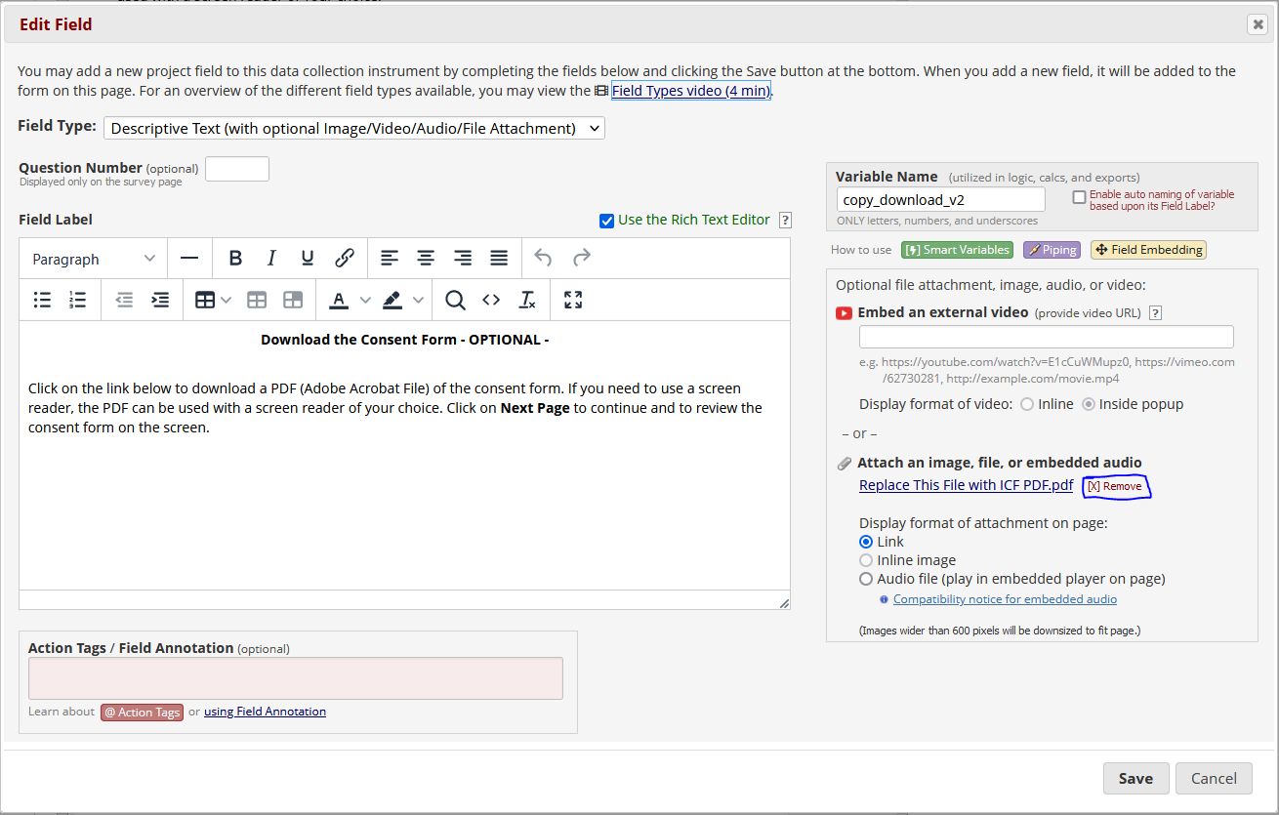
Once you have removed the existing file, click the green “upload button.”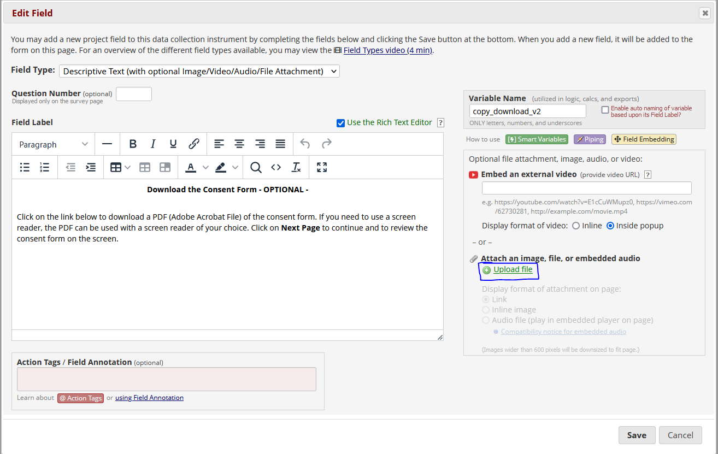
Select “browse” and select the PDF from your computer. Then, click upload file. The amended consent form’s name will be listed as the attached file. Once you have uploaded the amended consent form PDF, click “save.” The window will immediately close.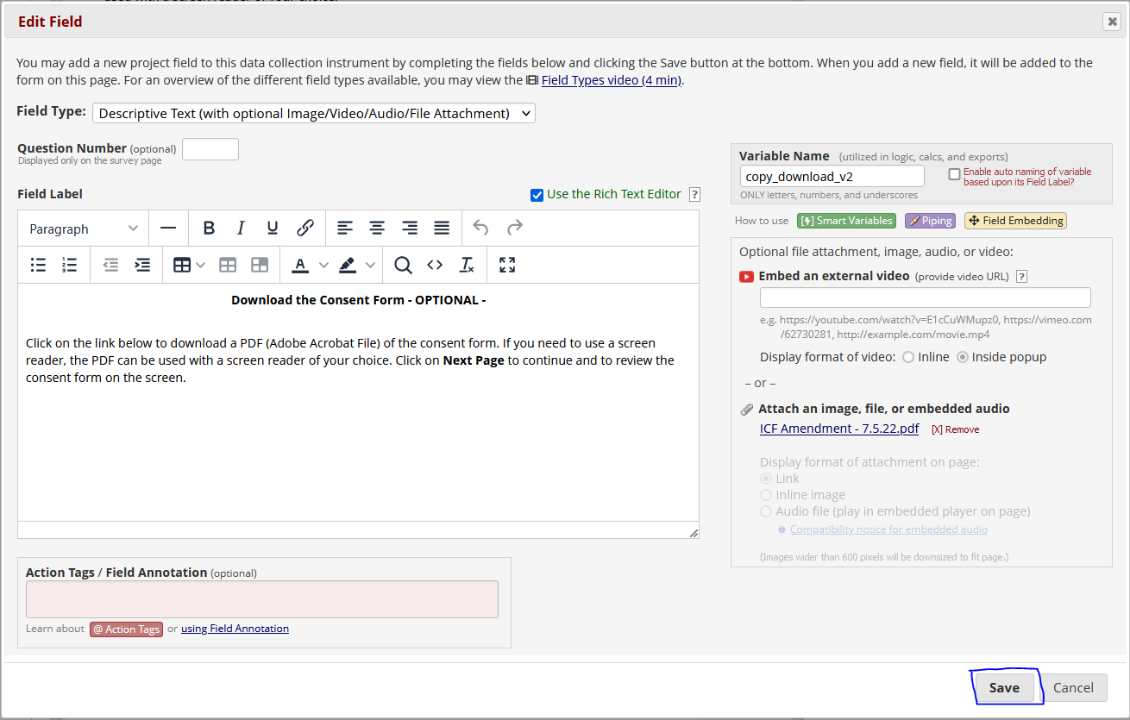
Repeat this process with the fields that house the consent form images. After uploading the image file to the field, select “inline image” to properly display the consent form images.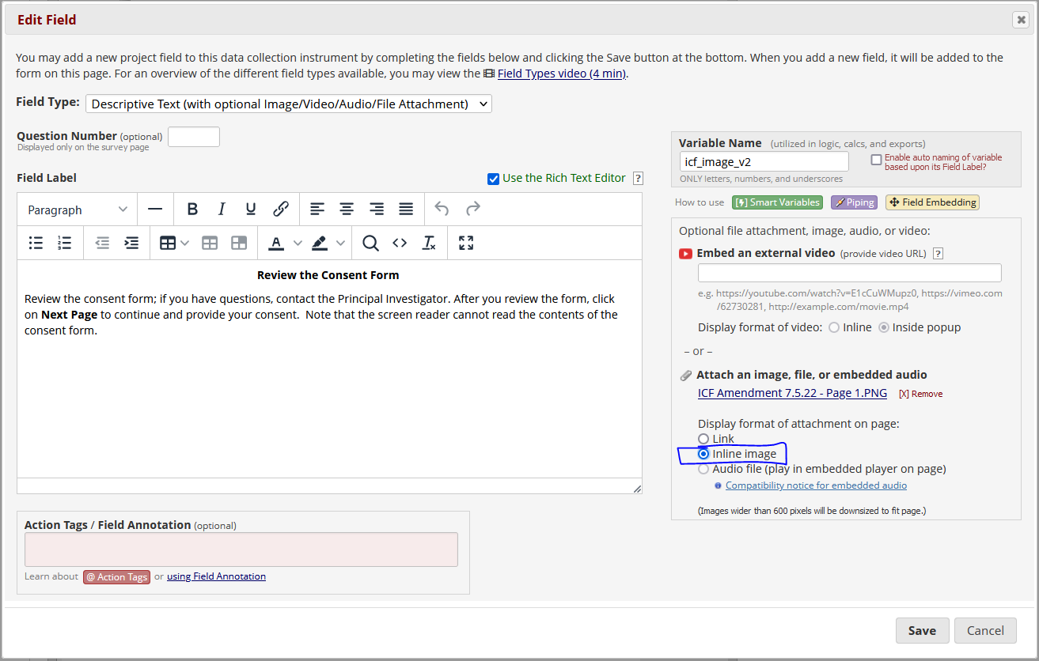
Upload each consent form image to the existing fields. If the length of the amended consent form differs from the original consent form, fields can be added or deleted by using the copy icon (double rectangles) or the delete icon (red X) at the top of a field. 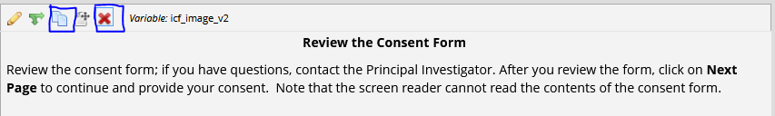
Once you have confirmed that all amended consent form images are being displayed properly, return to the project designer. Click on the red “automated invitations” button to the right of the original consent form. Then, click “save and copy to other surveys” at the bottom of the window.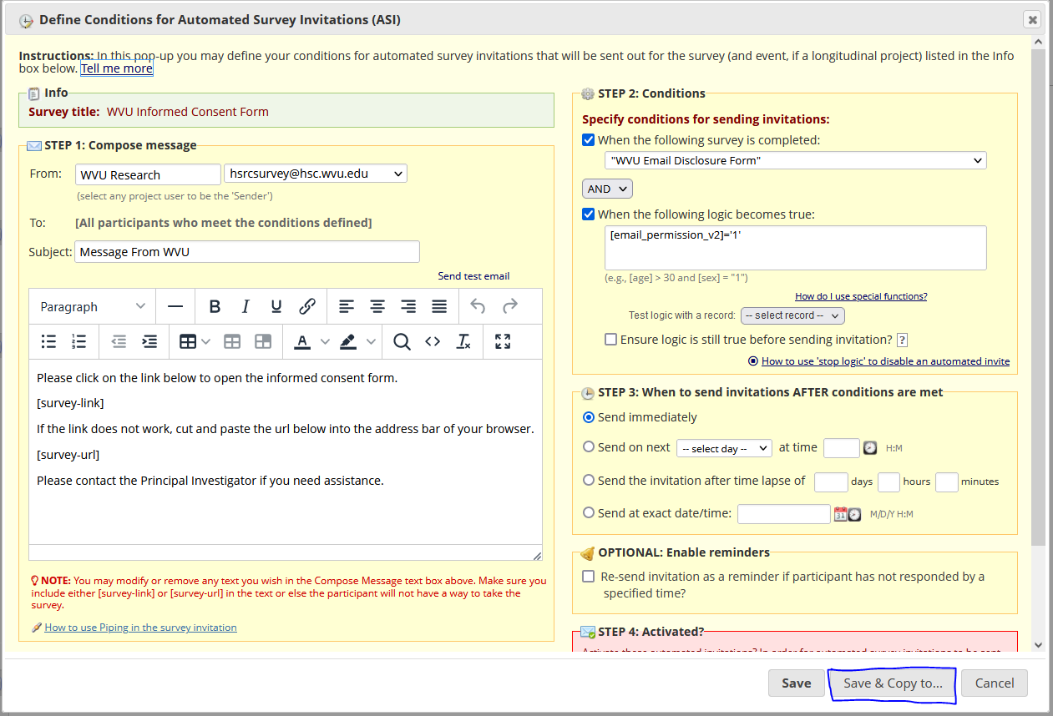
Another window will appear. Select the “WVU Informed Consent Form” instrument and click copy.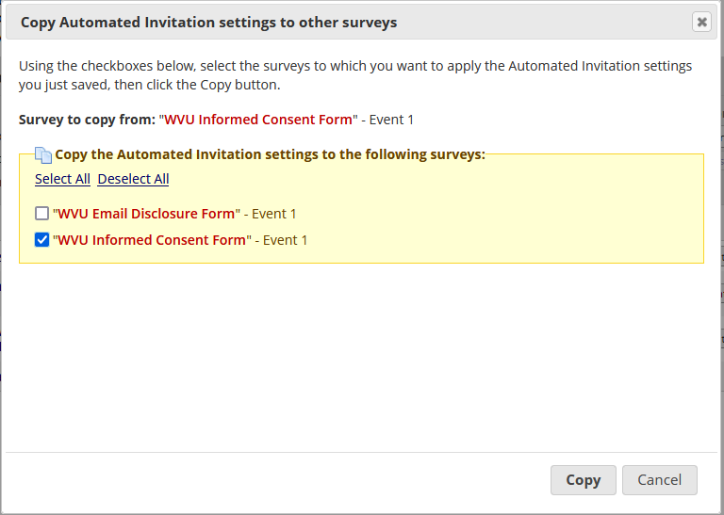
This will copy any existing invitation logic to the amended consent form instrument. Click on the red “automated invitations” button to the right of the amended consent form. Under step 4, click “active,” then “save.” 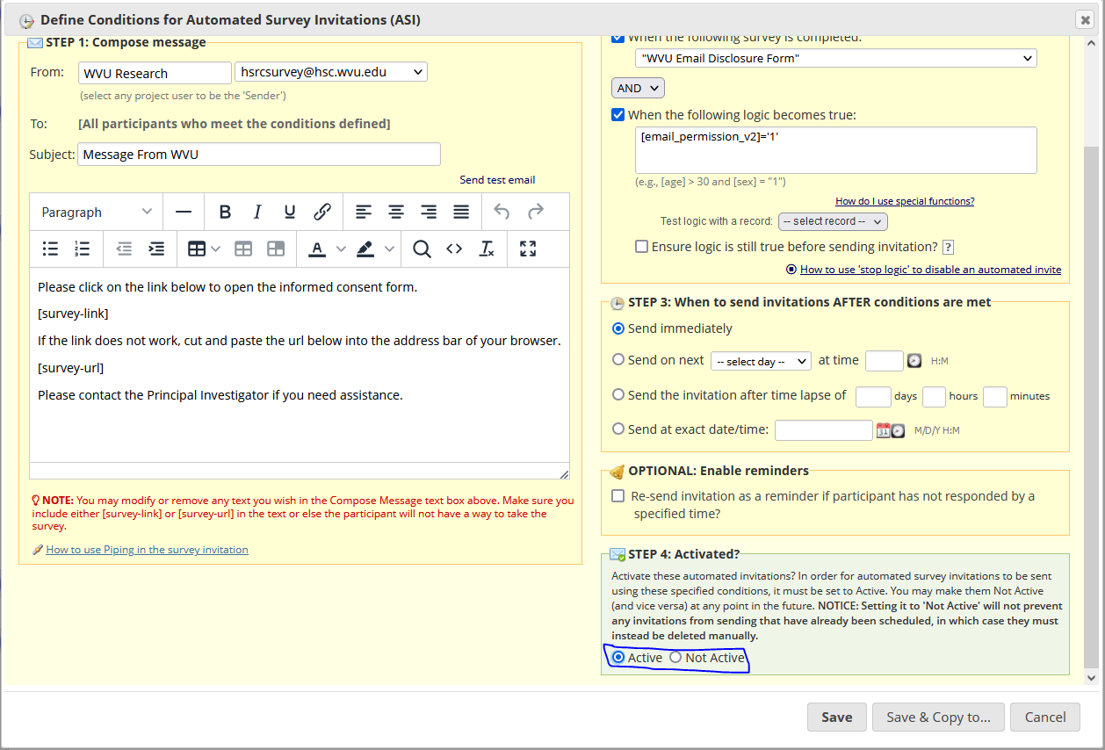
The automated invitations button will turn green to indicate that it is now active. Last, click “submit changes for review” at the top of the page. Please note that the changes will not take effect until the REDCap administrator has approved the changes. If the survey is opened before the changes have been approved, the outdated consent form will be displayed.

