November 2025 V3.0

REDCAP
ELECTRONIC INFORMED CONSENT
START GUIDE
WVU OHRP/WVCTSI

REDCap Electronic Informed Consent (eIC)
- Use these instructions ONLY when WVU is the IRB of Record.
- REDCap eConsent forms do not use an eSignature field. The REDCap eConsent Framework captures the agreement to participate as a digital signature by asking the participant/LAR to check a box containing text related to the agreement. The eConsent Framework (a feature in REDCap) locks the record and provides other information and technical features required for federal regulations and institutional policy. For additional information, please refer to the documentation in REDCap. Note that the eConsent Framework meets FDA certification requirements. When discussing consent with participants/LARs, be sure to use the word "signature" carefully as the participant/LAR will not SIGN the form using the traditional method of signature.
- WVU OHRP provides this guide but is not able to directly support study teams with the development of eConsent materials. It is the responsibility of the study team and ultimately the PI to fully understand the eConsent process.

Access REDCap
Log in to https://redcaplive.wvctsi.org/redcap/ using your WVU credentials.
If you do not already have a REDCap account, follow the instructions listed on this page to submit a REDCap account request through iLabs.

Locate the eTemplates
The eTemplates are available in the REDCap Library.
The eTemplates can be customized.

To create an eTemplate :
  - Click the "+ New Project" tab at the top of the screen

Select "Use a template (choose one below)"
  - Choose the applicable eConsent template based on your research project.

  - Ensure your project title includes the PI last name and protocol number as well as the full project title. Example: Smith 1234528591 Title of Study Here
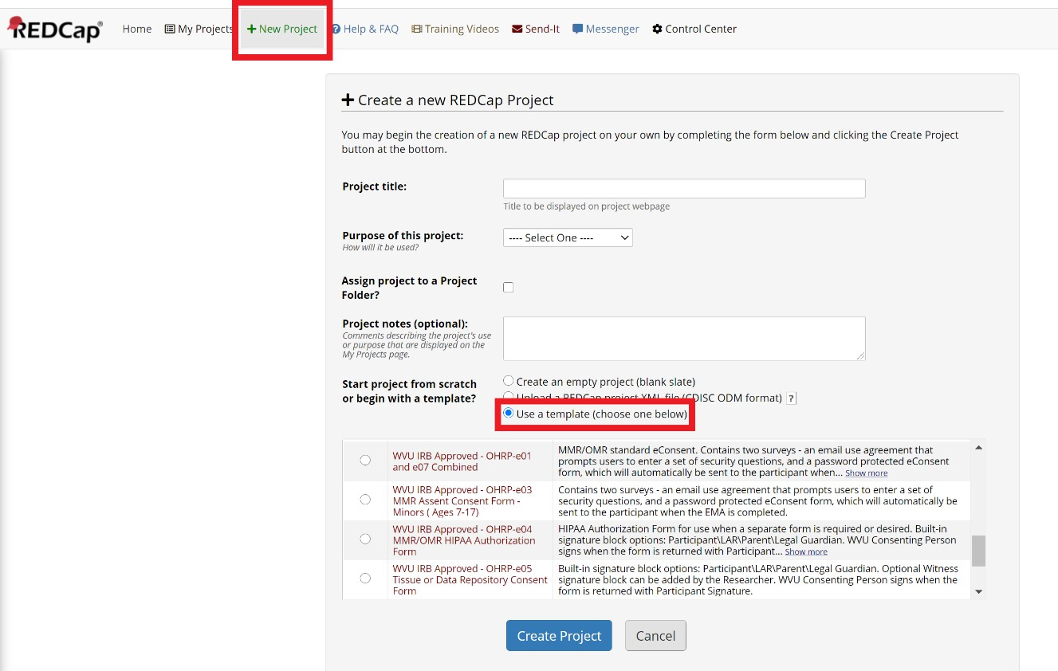

Verification of Identity (Required for FDA regulated research)
FDA guidance for eIC requires the consenting researcher to verify the identity of the person who will sign the consent form from a remote location. The standard method is to view a formal ID while on the required HSC Zoom video session. If this is not possible, the researcher can use the three identity verification questions. The participant/LAR is asked to enter their first name, last name, and birth month. The participant/LAR is requested to enter their answers to the questions as a "login" when they click on the link to open the consent form.

Initial Protocol Submission

NOTE: All eConsent forms presented to a prospective participant/LAR must be included in the protocol submission.
The standard content provided with the eTemplates, including survey questions, email message text, subject lines, messages to the prospective participant, cannot be changed unless approved by the WVU IRB. Only Logos approved by University Relations can be inserted into the eTemplates.

Modifications could include additional questions, embedded videos, or links to websites. Note that all electronic materials that will be presented to the participant/LAR must be submitted to the WVU IRB (the link (url) and a PDF of the contents of the electronic material).

NOTE: After customization, the eTemplate is considered an eConsent Form and is in a draft state similar to the Informed Consent Form. The draft contains a "placeholder" PDF for ADA compliance and a "placeholder" image file. The PDF and the image file will be replaced after WVU IRB approval.

- Modify the eTemplate to include the PI name and contact information and activate automated survey invitations for the consent form.
The WVU IRB requires that a researcher(s) be designated to monitor returned responses. When completed forms are returned to WVU through REDCap, email messages are sent to the addresses included in the Survey Notification option.
Click "Designer" within the Project Home and Design menu section
  - Click "Survey Notification" within the Survey Options section
  - Select the researchers to be notified by selecting their email address in the drop-down list.
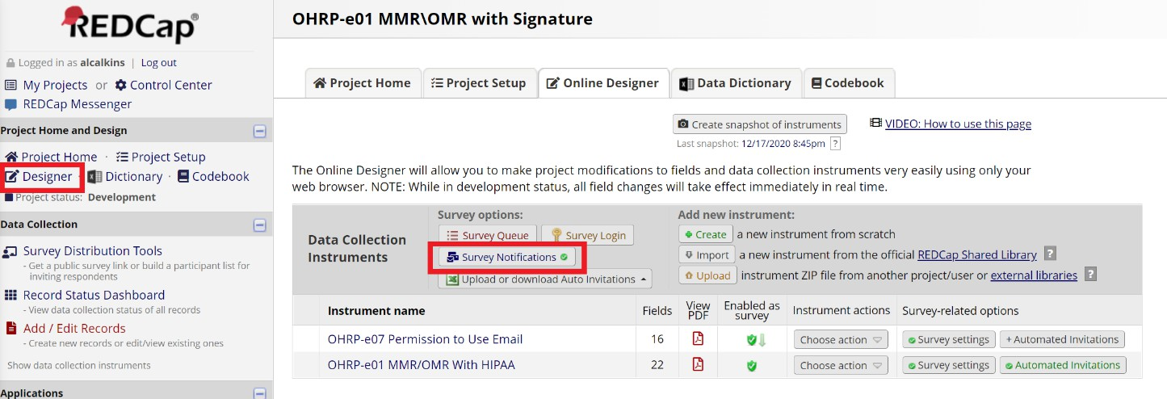

Ensure Automated Invitations are Activated for the eConsent. Click the red "automated invitations" button next to the consent form instrument and click "active" under step 4.

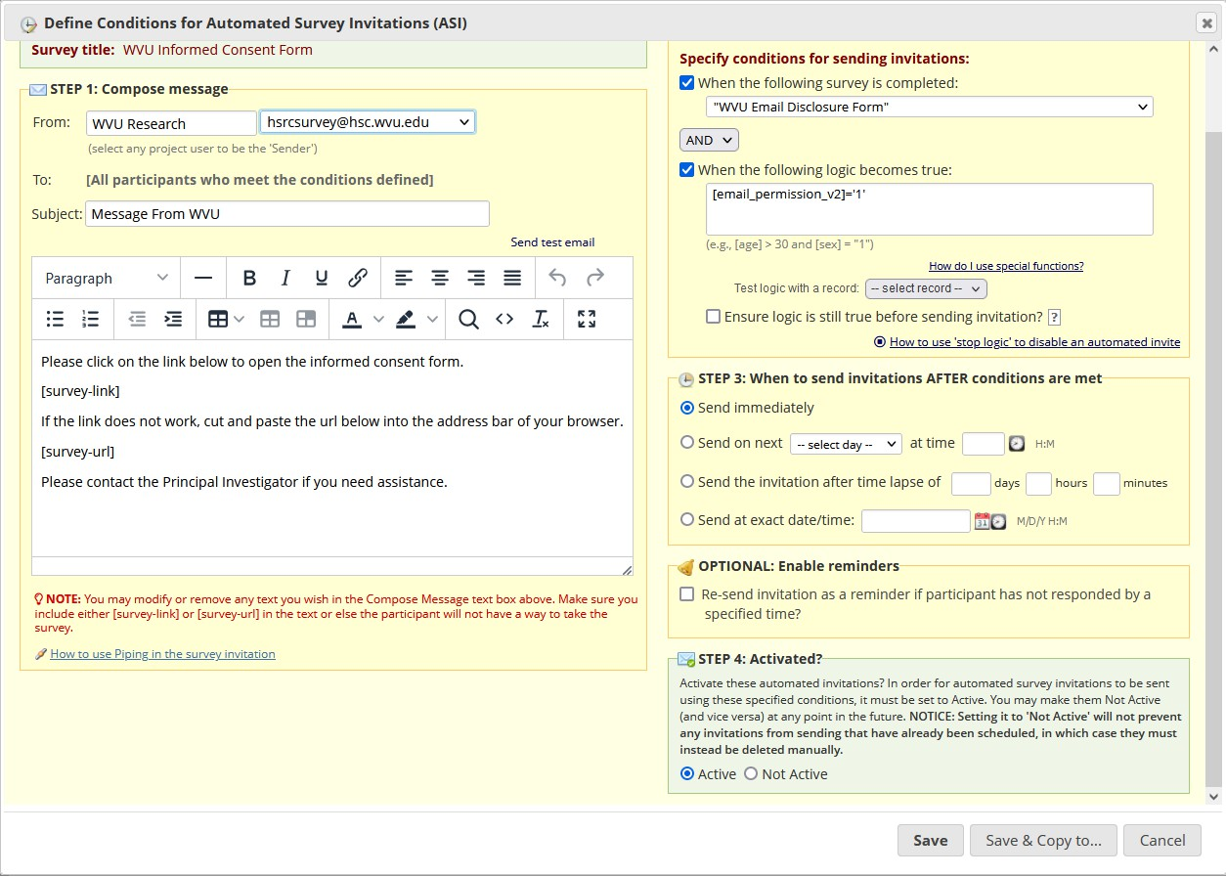
- Obtain the link (url) for the eConsent Form to include in the protocol document:

Select SURVEY DISTRIBUTION TOOLS from the menu to the LEFT of the screen.

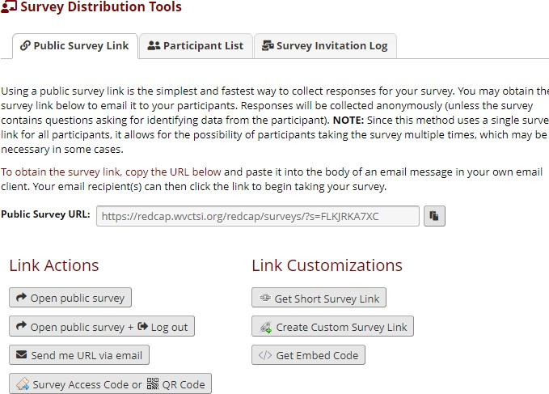
Click on the COPY icon (see red arrow) and PASTE the link in your protocol document.

- To obtain a PDF of the eConsent Form to attach in your protocol submission:
  - Select the ONLINE DESIGNER TAB from the menu at the top of the screen.
  - Click on the Adobe PDF icon, a file will be downloaded.
  - Attach the file to the protocol submission.
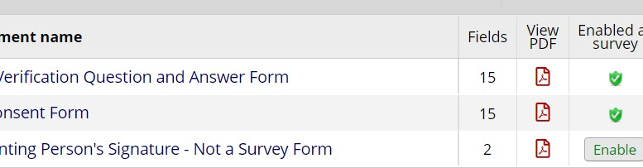

Determining and Configuring Distribution Methods.

NOTE: Links (urls) cannot be sent using WVU, HSC, or WVU Medicine email systems; all electronic information consent materials MUST be sent within REDCap. The REDCAP Participant List should be used to send eConsent forms.
There are multiple options for distribution depending on the research project requirements. Please refer to the REDCap documentation and discuss distribution methods with the WVU REDCap Administrator.

In-Person Consent
When using eConsent forms in-person, an email can be used to provide the link (via the participant distribution list function in REDCap) or manually on a device provided by the study team (no email needed).

Remote Consent
The participant distribution list function is REDCap must be used to email the survey to the participant.

After WVU IRB Approval:
After the WVU IRB approves the protocol, the Informed Consent Document must be attached to the eConsent Form as a PDF. Each page must be uploaded as an image file (replacing the placeholder pages).
  - Move project to production.
  - Attach the approved watermarked PDF of the Informed Consent Form or Cover Letter for ADA Compliance
Replace the "placeholder" document by uploading and attaching the PDF of the approved and watermarked informed consent document . The PDF is required to enable the document to be read by a screen reader. The document in the electronic consent form is an image and cannot be read. This PDF is for review only; it should not be signed. The signature is obtained electronically using REDCap through the REDCap eConsent Framework – Note that this is not an eSignature where the person uses a mouse, finger, or stylus to "draw" a signature; it is a checkbox.
  - Upload the image files for each page of the IRB Approved and Watermarked Informed Consent Form.
After completing this step, the Informed Consent Document will be visible within the eConsent Form as an image file. Including the document facilitates the discussion between the consenting person and the prospective participant/LAR. The page breaks to allow for a pause after each page to ensure understanding (federal and institutional requirements).
The images also enable REDCap to provide the participant/LAR with a complete PDF of the signed informed consent document (the eSignature and the approved/watermarked Informed

Consent Document); without the images, the PDF would only include the answers to the REDCap survey fields.
To display your consent form within the eTemplate survey and to facilitate a complete PDF of the consent form with eSignatures:
    - Replace the tutorial image with a high-resolution image approved informed consent form.
    - Create the image by exporting a PDF of the informed consent form as a .jpg file or. PNG using a preferred PDF editor. Each page will be a separate file.
    - To upload the images to the survey form:
      - Add a field or edit the existing tutorial image
      - Set the Field Type to "Descriptive Text (with optional Image/Video/Audio/File Attachment)"
      - Select "Upload file," then choose the file
      - Select "Inline Image" for the "Display format of attachment on page."
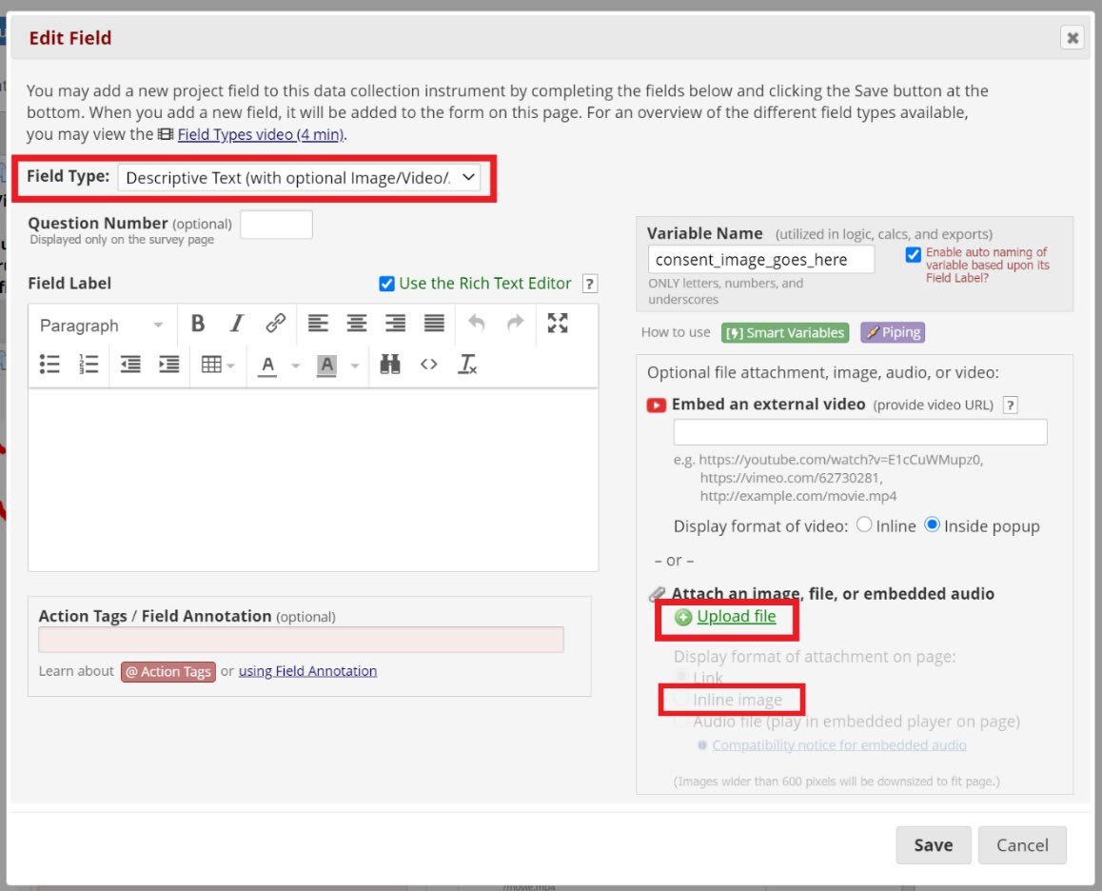
Scr
    - Add a page break (regulatory requirement) after each image.
      - Add a new field between two images
      - Set Field Type to "Begin New Section (with optional text)"
      - Click Save

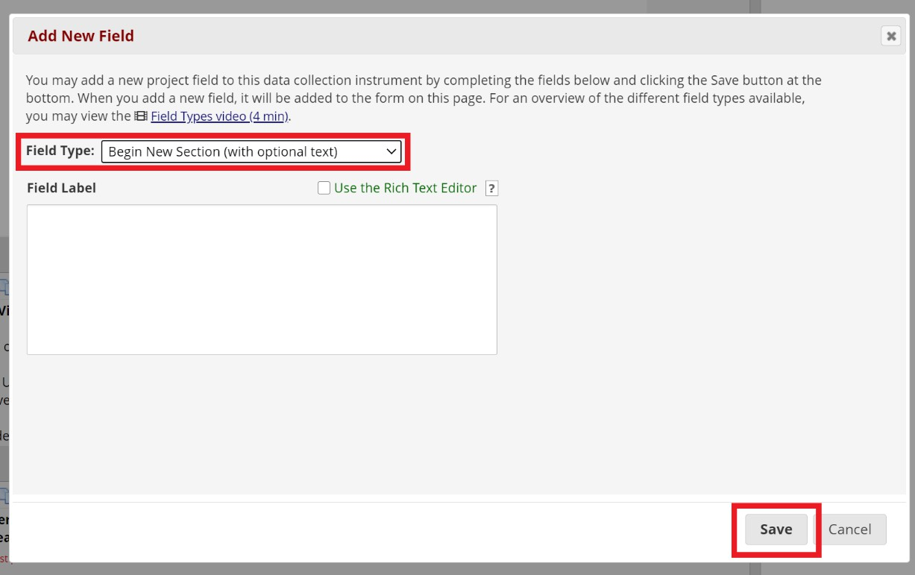
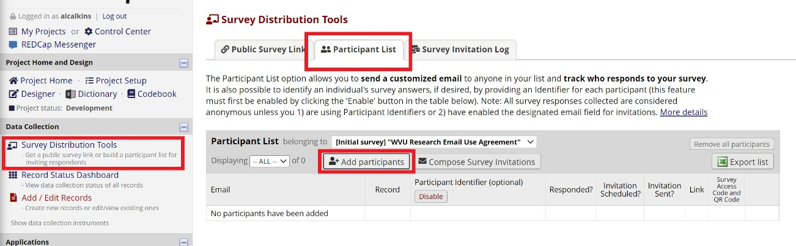

Create a Participant List
Create a Participant list.
- Click "Survey Distribution Tools" in the Data Collection section of the left-hand menu
- Click the "Participant List" tab towards the top of the screen
- Select the "Add participants" button
- Add the emails of the participants, one per line
- Click "Add participants."
- Click "Compose Survey Invitations"
- Compose the email invitation (this should be an IRB-approved message) and select the participants to receive the email invitation within the participant list checkbox, then click "Send Invitations."
- You can add to the list as participant join.

Send the eConsent Forms
Using the approved distribution method, distribute the eConsent forms to remote and in-person prospective participants/LARs.

Access and Manage Responses
Email messages will be sent to notify of returned responses to the email addresses entered in Survey Notifications
To view the eConsent forms that have been submitted by participants, select "Record Status Dashboard" in the Data Collection section of the left-hand menu. This screen will display a table listing all existing survey responses.
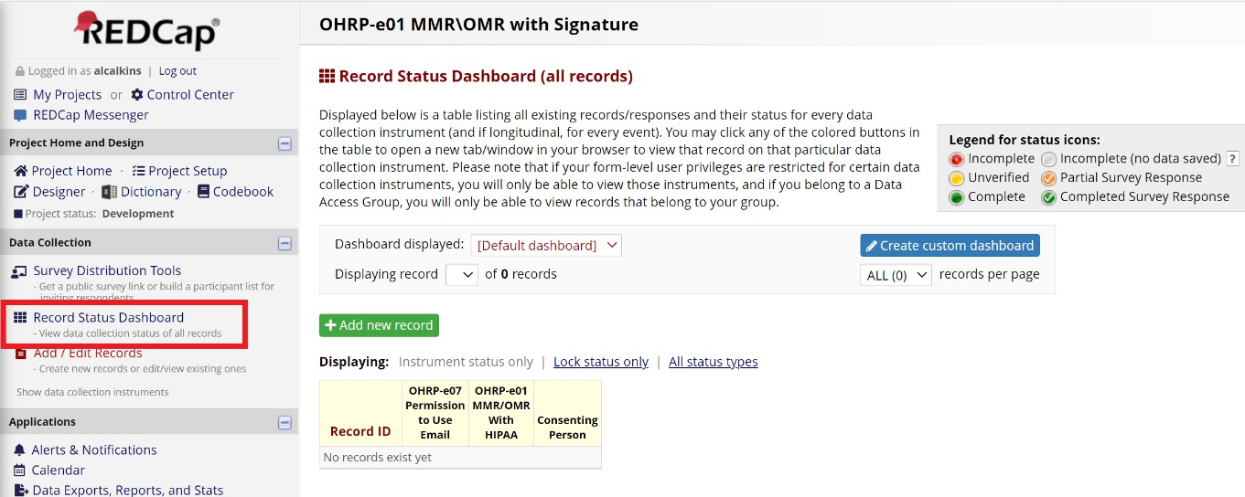

Consenting Person Signature (Required for greater than minimal risk studies or those subject to ICH-GCP E6)
When a participant has returned a form, the consenting person must sign the eConsent Form using the "Consenting Person" instrument included with the REDCap eTemplate project. The consenting person will navigate to the Record Status Dashboard and select the status icon for the appropriate Record ID.

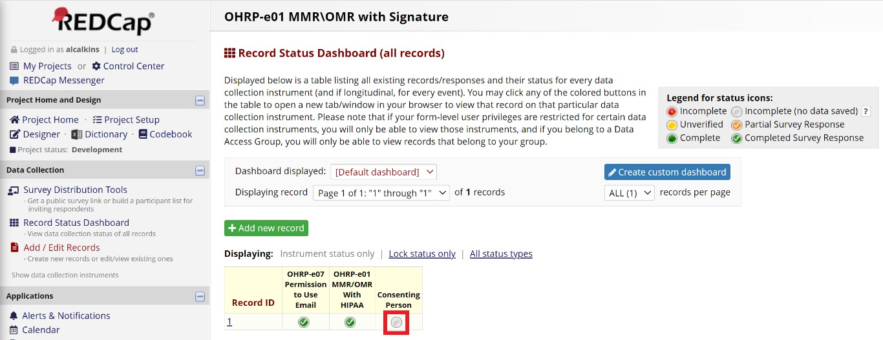
The consenting person will complete the two fields, Consenting Person's Full Name and Consenting Person's Signature.
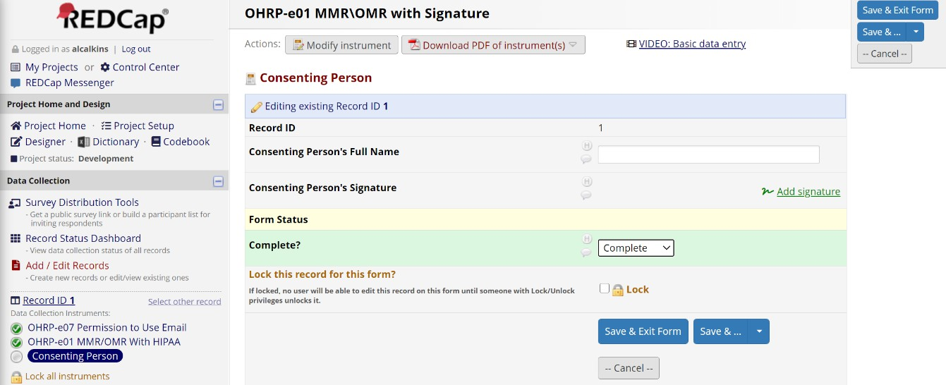

Send the Fully Executed eConsent Form to the Participant or LAR.
If you study is required to comply with ICH-GCP, the fully executed copy containing the participant/LAR eSignature and the Consenting Person's signature must be sent to the person who signed the Form.
When the consenting person has signed the returned eConsent, a PDF can be sent via REDCap SEND-IT to the participant\LAR. REDCap Send-It is a secure data transfer application for sending and receiving documents.
Note: The SEND-IT feature can also be used to send the consent document to the participant if they fail to download their signed copy after they complete the form.

Emailing signed consent forms as attachments using an institutional email address is not permitted by the institution. All consent information must be transmitted using REDCap.

REDCAP SEND-IT:
  - Download the PDF of the fully executed eConsent Form:
- Select the Record ID for the appropriate record from the Record Status Dashboard
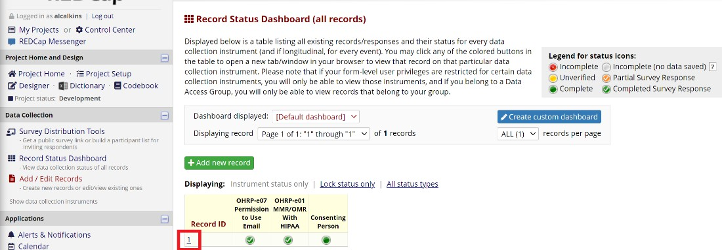
- Navigate to the "Choose action for record" drop-down and select "Download PDF of record data for all instruments."
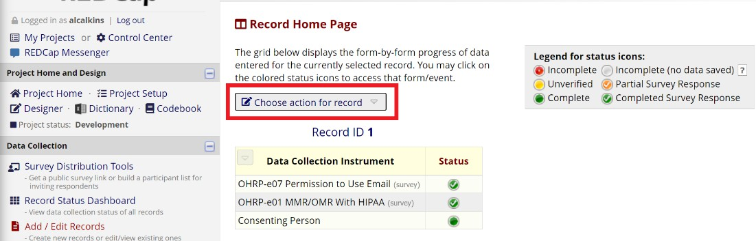
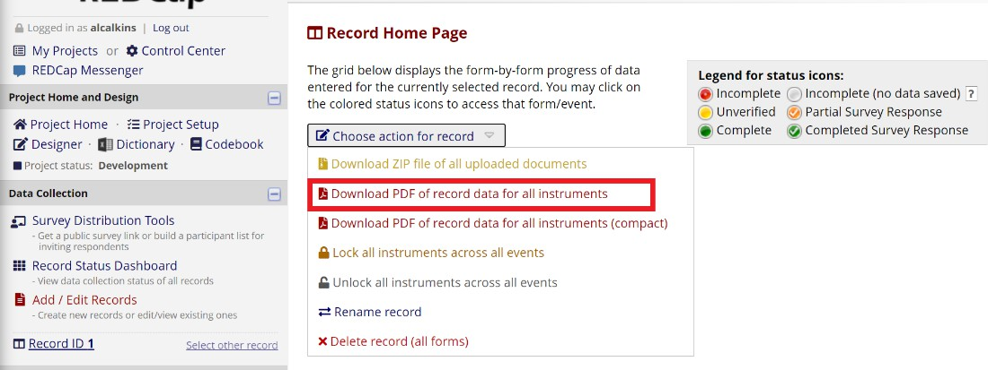

Send the PDF through REDCap Send-It:
- Navigate to the main "My Projects" REDCap page
- Select the "Send-It" tab at the top of the screen

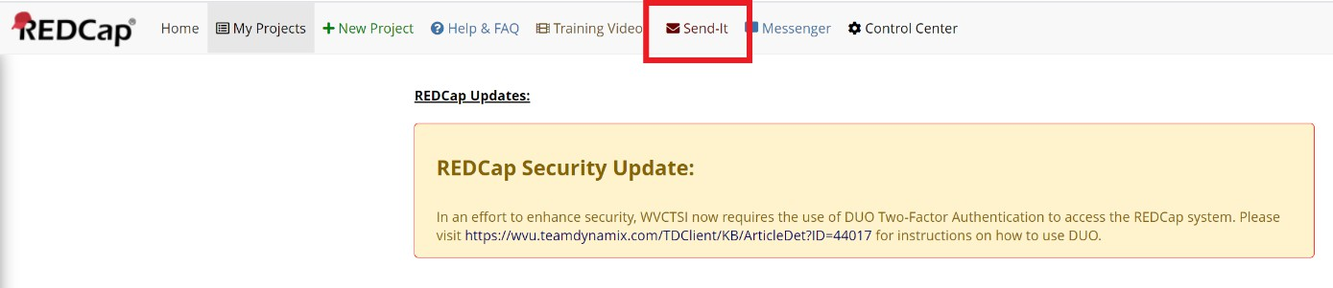
- Fill out the Form and specify to whom you wish to send the file
- Set the expiration to 14 days – REQUIRED; the WVU IRB must approve changes
- Check the box for "Receive confirmation?"
- Click "Send It!"
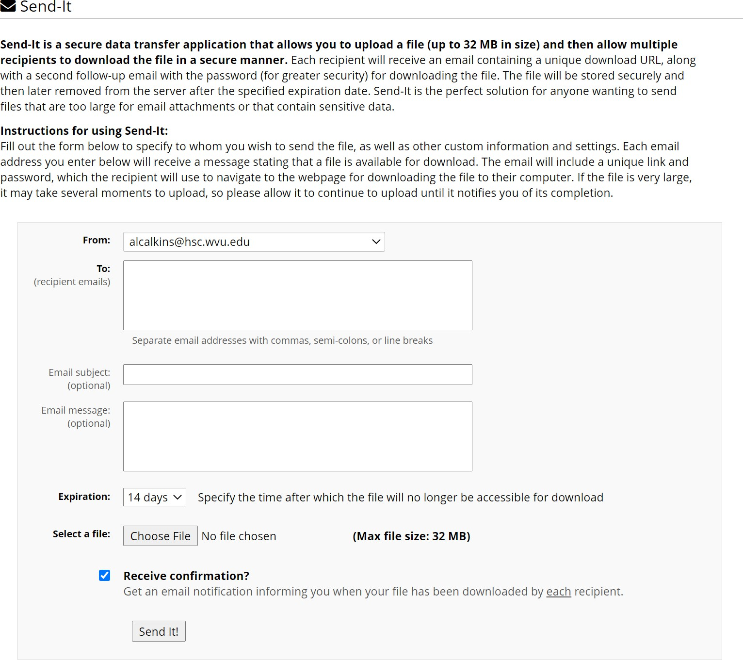

Submitting Revisions to the WVU IRB
Submitting modifications and requested revisions to the WVU IRB is the same process for all other modifications and revisions. Please see the applicable REDCap guides for replacing your consent document in REDCap to ensure you do not lose any data previously collected.

